Unit III Business Performance Measurement (BPM)

Definition, BPM vs BI, Summary of BPM Process, Performance Measurement, BPM Methodologies, BPM Architecture and Applications, Performance Dash boards.

- Definition of Business Performance Measurement (BPM):
Business performance measurement (BPM) refers to the management and analytical process employed by the management of an organization to assess the performance of the organization to achieve the goals pre- defined by the management of the organization.

BPM may be defined as “different business tools, techniques, methodologies and metrics employed by an organization to measure, monitor and manage the performance of the business enterprise”.

- BPM vs BI:
Key differences of BPM and BI:
Meaning:
- BPM: BPM refers to the different tools, methods and metrics employed by an organization to measure, monitor and management business Performance.
- BI: BI refers to the art and science of analyzing any data or information, with a specific business Objective.

Scope:
- BPM: The Scope of BPM is wider.
- BI: The Scope of BI is comparatively narrower.

Tools Used:
- BPM: BPM employs multiple tools, methods and metrics, which includes all the BI tools as well.
- BI: BI employs a wide variety of tools and techniques such as OLP adhoc querying, dashboards, scorecards etc.

Processes Involved:
- BPM: It involves multiple processes including BI+, Planning, cycle of plan, monitoring and analyzing of Business Performance.
- BI: BI processes are limited only upto analyzing of Business Data.

Nature:
- BPM: BPM is highly flexible in nature and is actively integrated with the ongoing organizational projects.
- BI: BI is static in nature. Its primary focus is upon measuring the performance of already completed business projects.

- Summary of BPM Process:
Business performance measurement (BPM) refers to the management and analytical process employed by the management of an organization to assess the performance of the organization to achieve the goals pre- defined by the management of the organization. Business performance management is also known as corporate performance management or enterprise performance management.
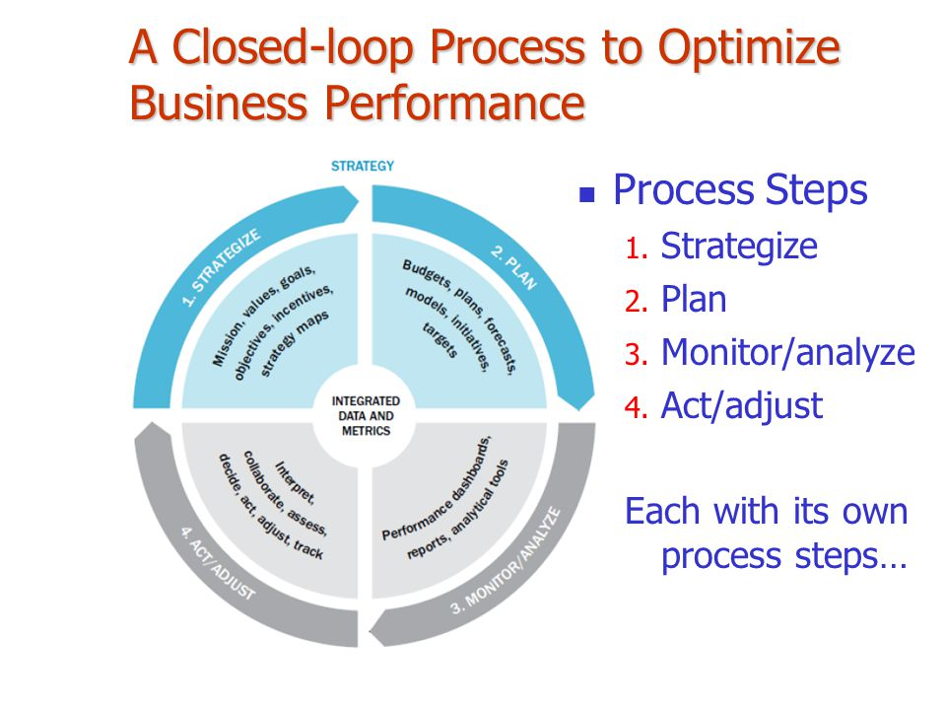
Summary of Business Performance Management Process:

- BMP is a set of integrated, closed-loop management and analytic processes, supported by technology, that address financial as well as operational activities.
- BPM is an enabler for businesses in defining strategic goals, and then measuring and managing performance against those goals.
- Core BPM processes include financial and operational planning, consolidation and reporting, modeling, analysis and monitoring of key performance indicators (KPIs) linked to organizational strategy.

- Performance Measurement:
Performance measurement is the process of collecting, analyzing and/or reporting information regarding the performance of an individual, group, organization, system or component.

Performance refers to output results and their outcomes obtained from processes, products, and services that permit evaluation and comparison relative to goals, standards, past results, and other organizations. Performance can be expressed in non-financial and financial terms.

Measurement refers to numerical information that quantifies input, output, and performance dimensions of processes, products, services, and the overall organization (outcomes). Performance measures might be simple (derived from one measurement) or composite.

There are a number of challenges that are faced when designing an effective Performance Measurement System, these include the following:

- How to measure non-financial performance
- What measures to choose and why
- How to use them - what to do with the results
- Who should be responsible for using the results
- How and to whom, to communicate the results
- The resources needed to consider the above and design and deploy the measurement system

- BPM Methodologies:

Methodology Element | Specific Procedures or techniques
Management | List of all core and support processes; list and definitions of leadership and team roles and responsibilities .
Process improvement with phases | Definition of phases; examples of required and optional work products in charter, discovery, analysis and redesign phases
Measurement | Data elements for before and after; analytical data elements; customer data, competitive data, and ongoing monitoring data. Decisions from data.
Learning |  | Skills needed for BPM techniques; delivery of training and real time learning; learning for BPM leadership, project and team roles
Alignment with Organizational Priorities |  | Techniques to prioritize processes such as strategic plan, SCOR, Enterprise architecture, 3 x 3 box performance criteria
Continuous Improvement |  | Roles, monitoring frequency, monitoring methods and signals
Technology |  | Standard technologies used across the enterprise. Where are custom technologies used and why?
BPM Common Practices |  | Agreed internal common practices, such as roles, analysis techniques, group, assessment
Change Management |  | Change management model with steps. Method to assess gaps and potential solutions to close gaps. Choice of internal method, or method from external consultant.

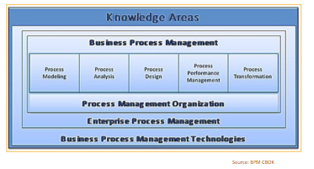

- BPM Architecture and Applications:
BPM Architecture:
BPM architecture is intended to ensure that a company automates its business processes. It can be said that BPM architecture is a general definition of an entire system of processes. The intended use of good BPM architecture is to improve processes and hence optimize results.

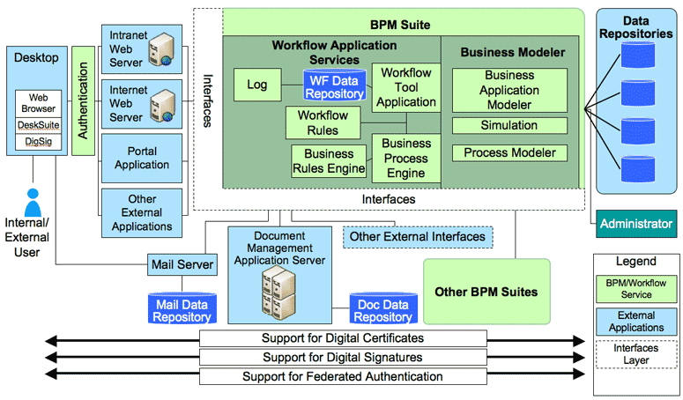

BMP Applications:
Business process management (BPM) is a systematic approach to making an organization's workflow more effective, more efficient and more capable of adapting to an ever-changing environment. A business process is an activity or set of activities that will accomplish a specific organizational goal.

- Performance Dash boards:
A dashboard report provides visual feedback on the performance of a business, department, project, or campaign. However, an effective dashboard provides more than just a summary of relevant data - if insight and analysis are also included, a dashboard can be a great tool for quickly reviewing key metrics as well as actions that need to be taken.
The people collecting and analyzing data may not be the final decision-makers, so including analysis and recommended actions in the dashboard can create a more useful report. Additionally, this can help close any communication gap between analysts and executives who need thorough information in order to make strategic decisions. Ultimately, a dashboard has the potential to save time, provide clear communication, and drive business goals in the right direction.
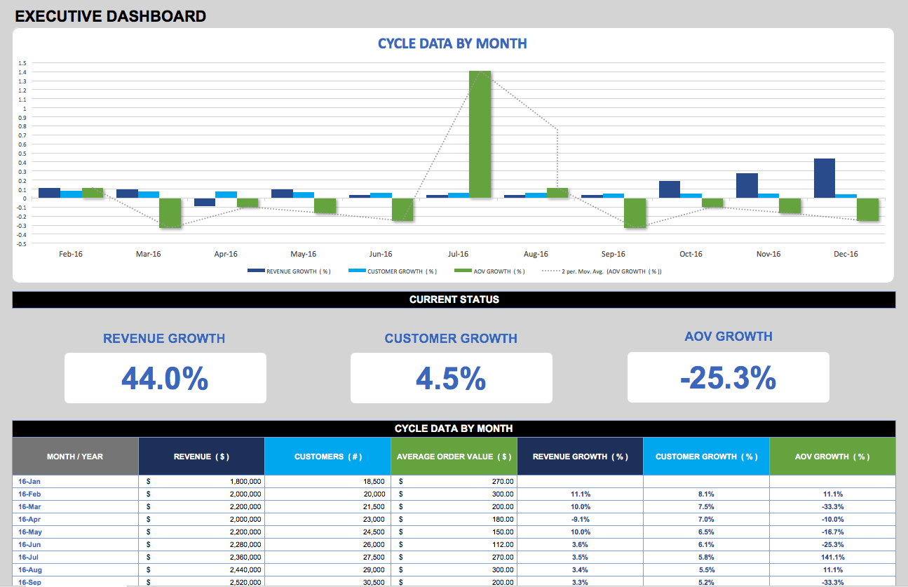
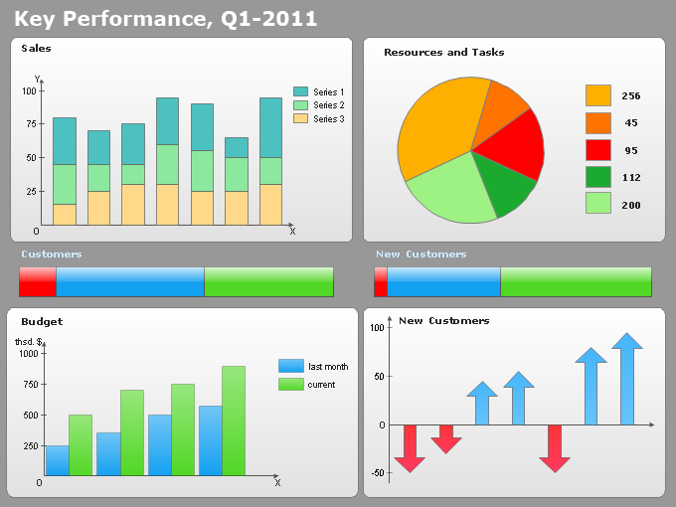
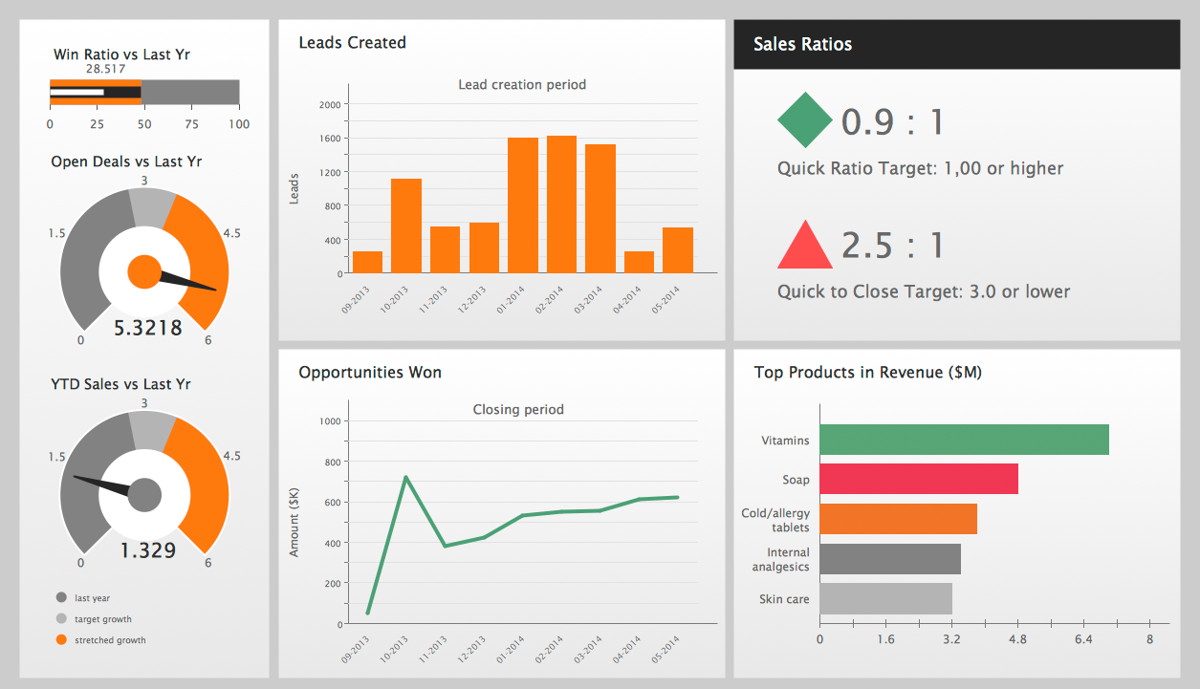
END OF UNIT-3

